VACUUM FORMED RETAINER

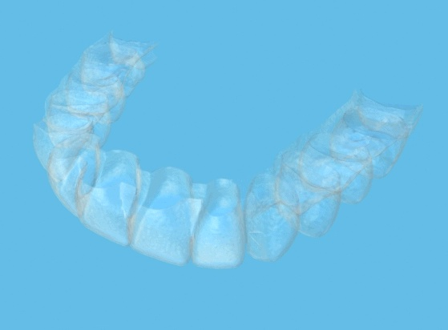

Q What is a Vacuum Formed Retainer?

A A vacuum formed retainer is a thin brace made from a sheet of clear plastic, which looks similar to a gum shield in shape.

Q Why is a Vacuum Formed Retainer needed?

A This retainer is needed to stop teeth moving back after the fixed brace is removed.

Q What is the difference between a Vacuum Formed Retainer and other retainers?

A The vacuum formed retainer prevents any movement of the teeth and is easy to wear. This makes it popular with many patients.

Sometimes a Hawley retainer made of plastic and wire is better because it is stronger and allows for the back teeth to settle slightly.

Q Will my Orthodontist or Dentist provide this retainer?

A Your Orthodontist will provide the retainer for use after the removal of your fixed brace.

Q When will I need to wear it?

A You will need to wear the retainer at nights.

Q How long will I need to wear it?

A You will need to wear the retainer for at least one year following the removal of your brace. Many orthodontists now recommend wearing your retainer until all growth ceases at around 22 years of age.

Q What will happen if I don’t wear the retainer as recommended?

A Your teeth will almost certainly move if you don’t use your retainer as recommended.

Q How do I clean my retainer?

A You should use a toothbrush and soap. Do not use toothpaste as some products can damage the plastic of the retainer. If you are cleaning the retainer over the sink, as a precaution put water in the sink in case you drop the retainer. Proprietary cleaning agents are available.

Q What happens if I lose or damage my retainer?

A You will need to contact your orthodontist as soon as possible for a replacement.

